DUPLICATE THIS FORM AS NEEDED.
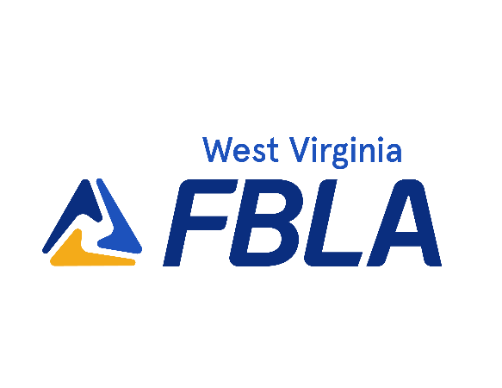
Proctor Certification Form
Pre-Conference Assessment - Online Test

As a Proctor for the FBLA online events, I certify that the following statements are true:

I. I received correspondence with login information for each competitor.
- I administered the test(s) on the following date(s): ____________________________________________

- I watched the competitor(s) complete the tests online.

- I was the only person in the room, other than the competitor(s), during the testing.

- l gave no help to the competitor(s) beyond that allowed in the instructions (i.e., equipment problems).

- I verify that the competitor(s) used no textbook, reference materials, or calculators other than the one built into Blue Panda or a four-function calculator.

- I attest to the fact that no test materials were saved, copied, or printed in any way, and no test materials remain in my possession or in the possession of anyone else at this location.

- I certify that each participant completed his/her test in one session.

- I verified no cell phones or electronic devices were used by students during testing.

- I have each competitor sign in along with the test they took.

Proctor’s Signature: Date:

Proctor’s Name (Print): Title/Position:

Address (Stree/P.O.0: (City, State, Zip):

Phone (Daytime): School:

DUPLICATE THIS FORM AS NEEDED.
Objective Test Sign-In Sheet
Pre-Conference Assessment - Online Test

Student Name | Date | Objective Test | Student Signature

